The last two columns examined the impacts of having monopolies within the economy. They established that, despite popular opinions and accepted common knowledge that a monopoly can control everything within its sphere of activity, the reality is that a monopoly (or an oligopoly) is under immense pressures that narrowly limit its behavior. The structure and extent of these limits are best understood by analyzing marginal cost and revenue curves within the context of the supply-and-demand curves (see the previous two posts). These very forces limit the production of a monopoly to levels below the societally optimal value, which is the real complaint that society at large should have against the monopoly. A textbook case that demonstrates that market forces rule regardless of a company’s size is the tragic and disastrous MCAS system that downed two Boeing 737 MAX 8 and that has left the company’s reputation in tatters and its future uncertain.

The resulting economic conclusion, based on sound logic and observed outcomes within real business sector, is that monopolies do damage to consumers by keeping the supply lower than desired, not because of malice on its part, but because it has no choice (or rather it has no profit-optimal choice, which amounts to the same thing).

The natural follow-on inference is that it is in society’s best interest to eliminate monopolies; and, for many cases, this is true. However, there are times when a monopoly is societally beneficial if not outright necessary.

The prototype example of this ‘exception’ are those industries that deliver services that require wide-spread standardization. The most obvious examples are utilities that deliver gas, electricity, water, and telecommunications to a community.

Imagine the chaos that would ensue if there were more than one electric company in your town. Each company, say Exciting Electric and Pinnacle Power, would have to construct its own delivery system (its own wires) to send electric power to the consumer. What a waste of resources: duplicate sets of power lines, consuming more land, and so on.

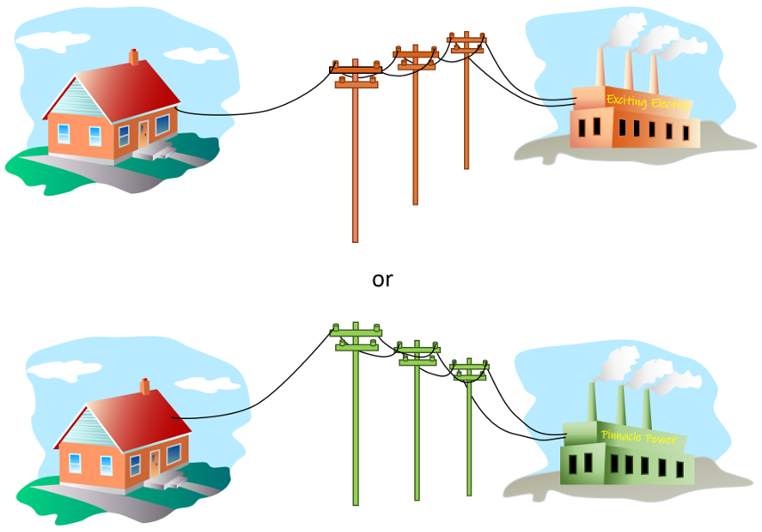

An additional concern is that each company would try to have a unique standard (say Exciting Electricity would use 60 Hz and Pinnacle Power would use 50 Hz) as a way of locking the consumer into their service. Based on these conclusions, local communities established utilities as essentially publicly owned trusts with a suite of regulations covering every aspect of the enterprise.

At least that’s how the conventional wisdom goes. And there is some truth in it, certainly in the past where the electric company owned both the power plant and the delivery system. But I think there are definite places for improvement.

To understand the possibility for improvement, turn to a utility that was deregulated after decades as a monopoly – telecommunications. The telephone infrastructure was essentially a regulated utility for decades. During this time, there was little innovation particularly where the consumer phone was involved. Since the phone company owned the phones in the consumer home, choices were limited to the standard model or the princess phone, available in a dazzling array of something like three colors: white, black, and beige. There might have been a red version but who cares, the point is that there wasn’t much choice nor was there any incentive to listen to customers. As a utility, the phone company could charge the consumer with a certain amount of impunity and provide services below what a competitive market would.

Many changes happened after ‘[Ma Bel](https://en.wikipedia.org/wiki/Bell_System)l’ was broken up in the 1980’s. Suddenly, there was a freer market and an incentive to innovate. However, the real change came with the invention of the cell phone. Here was about as free of a market as could be imagined. Different cell service providers sprang up, each providing access on the common, shared delivery system that is the electromagnetic spectrum; each offering competitive pricing, better service, and an increasing pace of innovation. The market started with ‘brick’ phones, evolved to more compact and slim designs, which then evolved to flip phones, and finally to the smart phones most of us enjoy today.

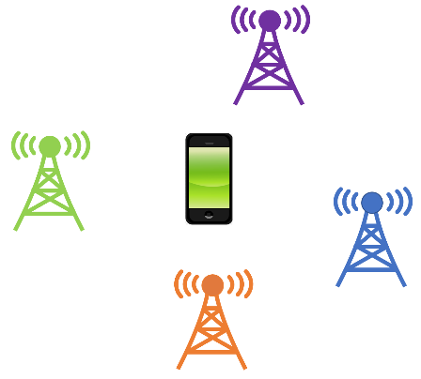

None of this innovation would have happened under the old system and the competition has lead to a much better experience for the consumer. Of course, none of the providers are perfect and there are times when the consumer has had enough with his particular provider and moves elsewhere, but that is just what a free market promises, a mechanism for improvement not a perfect finished system.

With these observations in hand, let’s return to the question of electric power generation and delivery. In *The Complete Idiots Guide to Economics*, Tom Gorman mentions in passing that deregulation has had mixed results. To quote:

Over the past [25] years or so, The United States has broken up several monopolies and introduced market forces into some formerly regulated industries, such as telephone service, power generation, and air travel. Results have been mixed. In the telephone business, greater innovation and lower prices for service have resulted. Lower prices have also resulted in air travel, but extremely high costs may render the industry ill equipped to function in a truly competitive environment. The jury is till out on power generation, but early signs in from California are not promising.

While Gorman’s analysis of telecommunications is spot on and his warnings about air travel seem to be reflected in the recent Boeing disaster one can’t help but wonder why he is so pessimistic about electric power generation. The probable answer is the manipulation of the energy market by Enron (the [‘burn baby burn’ scandal](https://www.cbsnews.com/news/enron-traders-caught-on-tape/)) but this situation was hardly the free market gone bad. There is ample evidence that government and industry were in cahoots resulting in [“secret deals with power producers, traders deliberately drove up prices by ordering power plants shut down”](https://www.cbsnews.com/news/enron-traders-caught-on-tape/) and that it was deregulation-in-name-only replete with [many flaws](https://www.consumerwatchdog.org/feature/what-wrong-californias-1996-deregulation-plan).

In the case of power generation, many markets have moved or can move to having a common delivery infrastructure structure with power generation being separately owned by different companies that compete for their market share.

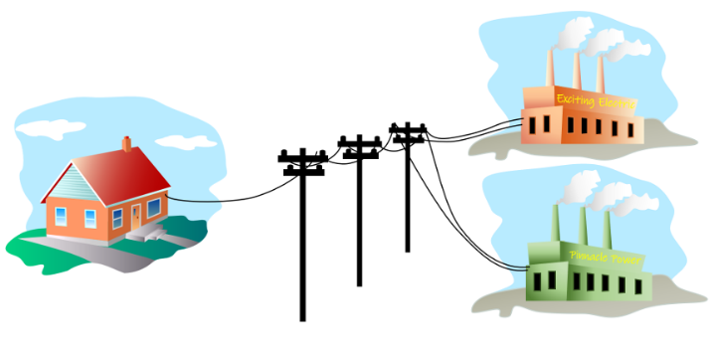

And at least some reports show that [power generation deregulation](http://ambenelectric.com/energy-deregulation/) works and can save the consumer up to 30%. So, the lesson is that seems that deregulation will work if some imagination and ingenuity is used to harness market forces, while preventing government and/or business placing thumbs on the scale, and that society should be actively working to eliminate or minimize the presence of even ‘blessed’ monopolies in the economy.